**EPROM** **Programmer**

Microprocessor Programming and Interfacing

(EEE/INSTR F241)



**Submitted by  
Batch No – 08**

VISHAL ASNANI 2015A8PS392G

AMARTYA BASAK 2015A3PS280G

AMAN KUMAR GOSWAMI 2015A8PS473G

PATIL SIDDHANT VITTHAL 2015A8PS475G

VIABHAV MALANI 2015A3PS160G

PAWAR GAURAV GANESH 2015A8PS393G

**COMPONENTS USED**

|  |  |  |
| --- | --- | --- |
| **SR.No** | **Components** | **Quantity** |
| 1 | Intel 8086 Microprocessor | 1 |
| 2 | 8255 Programmable Peripheral Interface | 4 |
| 3 | 6116 (2Kx8) RAM Chip | 2 |
| 4 | 2732 (4Kx8) ROM Chip | 4 |
| 5 | 74LS373 Octal Latch | 3 |
| 6 | 74LS245 Octal Tri-State Buffer | 2 |
| 7 | 27C64 (8Kx8) NMOS UV EPROM | 1 |
| 8 | 74LS138 3:8 Decoder | 3 |
| 9 | 8284 Clock generator | 1 |
| 10 | LED (green) | 1 |
| 11 | LED (blue) | 1 |
| 12 | LED (green) | 1 |
| 13 | 8253A | 1 |
| 14 | 7 segment display | 6 |
| 15 | Not gate | 1 |
| 16 | Button | 18 |
| 17 | SW-SPDT switch | 1 |

**MEMORY MAP**

|  |  |
| --- | --- |
| **Chip** | **Address** |
| ROM 1 | 00000H – 01FFFH |
| RAM 1 | 02000H – 02FFFH |
| ROM2 | FE000H – FFFFFH |
| 8255 (1) | 10H |
| 8255 (2) | 20H |
| 8255 (3) | 30H |
| 8255 (4) | 40H |
| 8253 | 50H |

ASSUMPTIONS MADE

1.In 2732 to program and verify Vpp must be changed from 25V for programming and 5V for verifying, thus requiring the user to keep switching the hardware to check after each successful write.

In 2764 to program and verify VPP is held constant and CE is connected to ground. Also while programming the programming pulse of 50ms is given and rest of the time kept high. So here the write and read can be executed without changing any hardware.

Owing to the fact that the data sheet and the timing diagrams of 2764 EPROM were more descriptive and illuminating than of 2716 we have used 2764. We think this is justified as the programming principles remain the same.

2.Backspace removes the latest nibble entered and displays **F** in place of nibble removed.

3.Incremental addressing is used for programming the EPROM.

4.SPDT switch is used for Vpp.

5.LED’s used are common cathode.

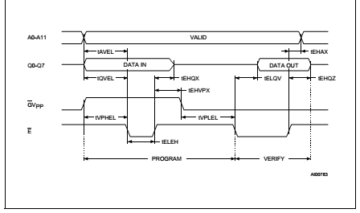Timing diagram for 2732

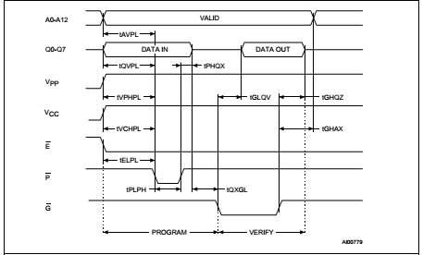 Timing diagram for 2764

Running the Simulation

After uploading the bin file, the simulation can be run. The next step is putting the SPDT switch at 5V.

Wait a few seconds and if red led labelled **not empty** glows then exit else switch the SPDT switch to 25V. Now enter the byte of data you want entered and then press enter. If green led glow labelled **Fail** glows, then exit and continue programming. If after programming all locations have been successfully programmed blue led labelled **Successful** glows.

Design Diagrams

1. Microprocessor and Demultiplexing Circuitry for System Bus

2. External RAM and ROM Circuitry

3. 8255,8253 and EPROM to be programmed

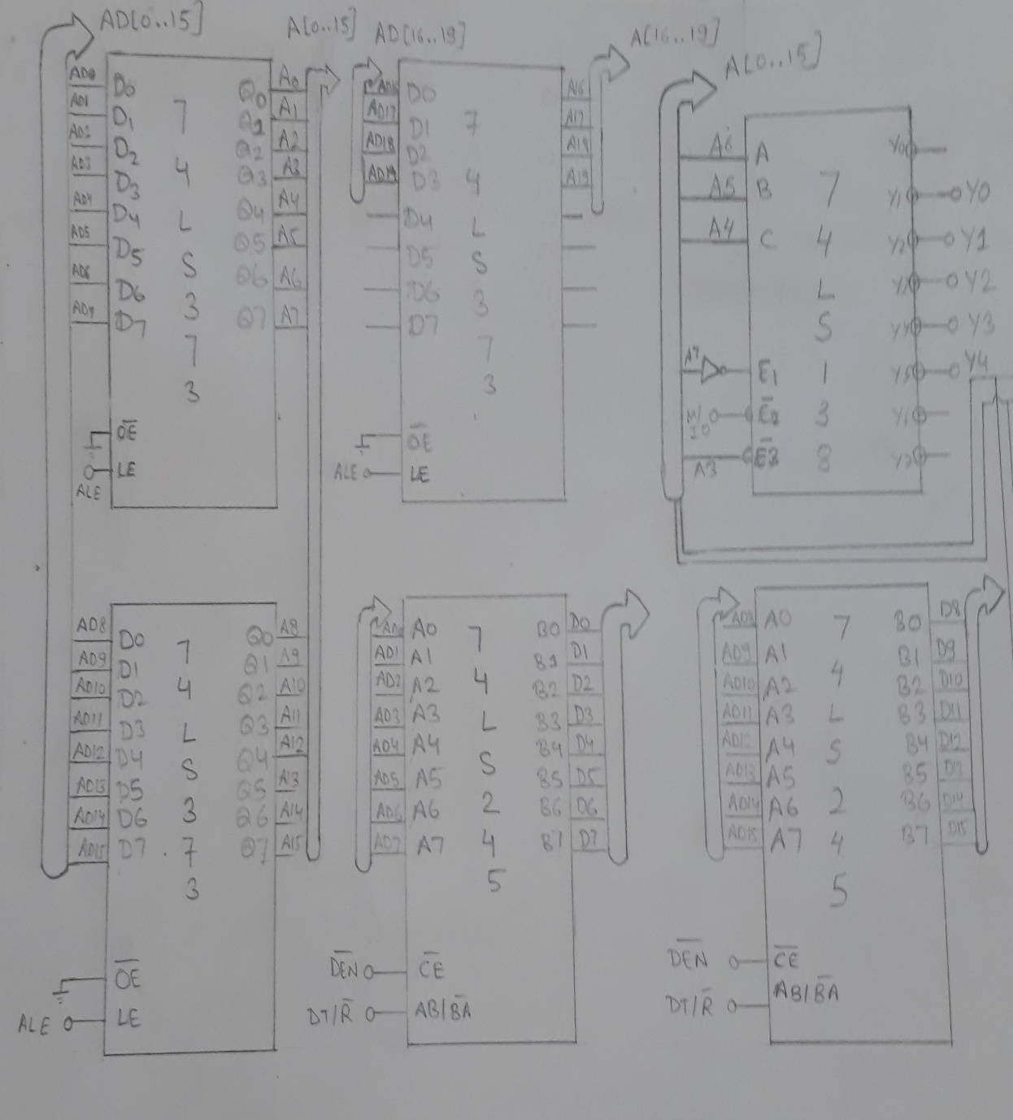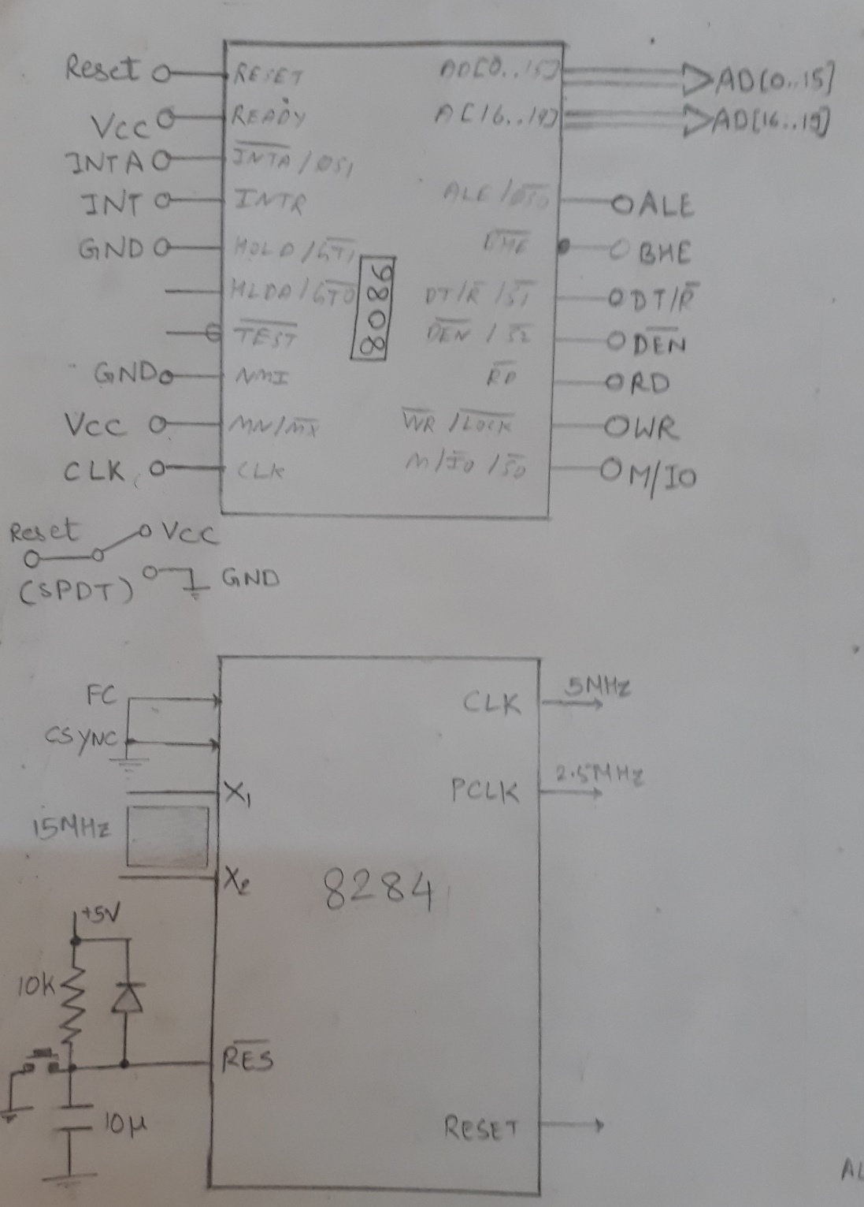

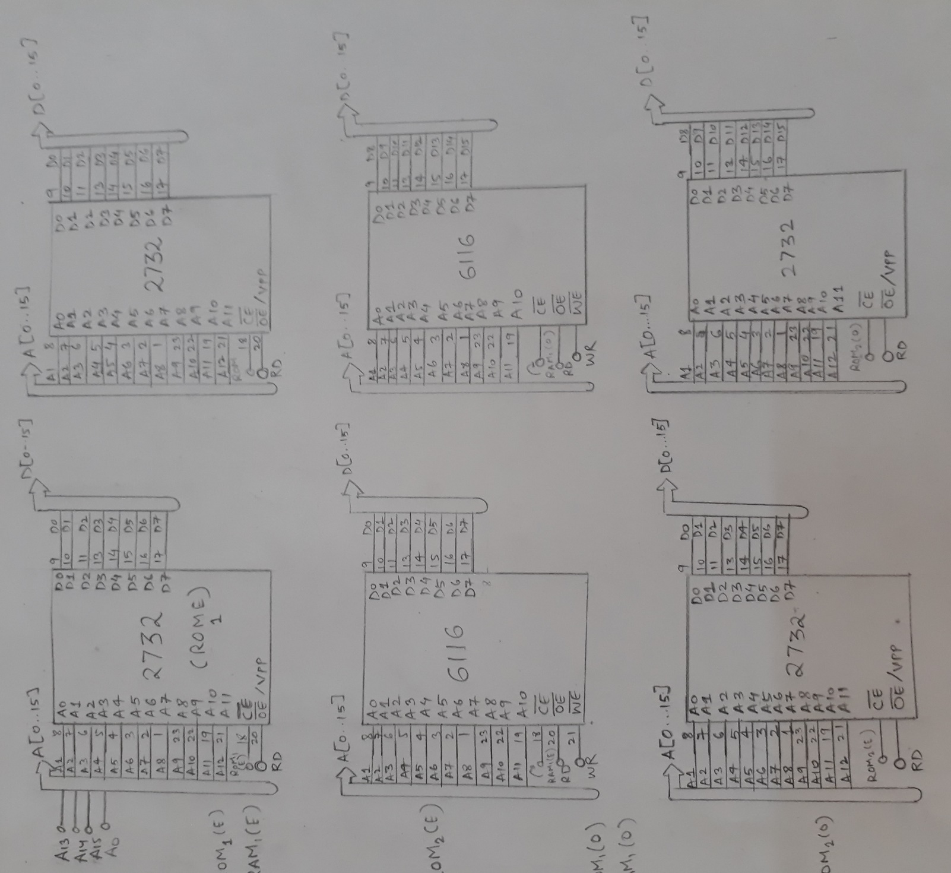

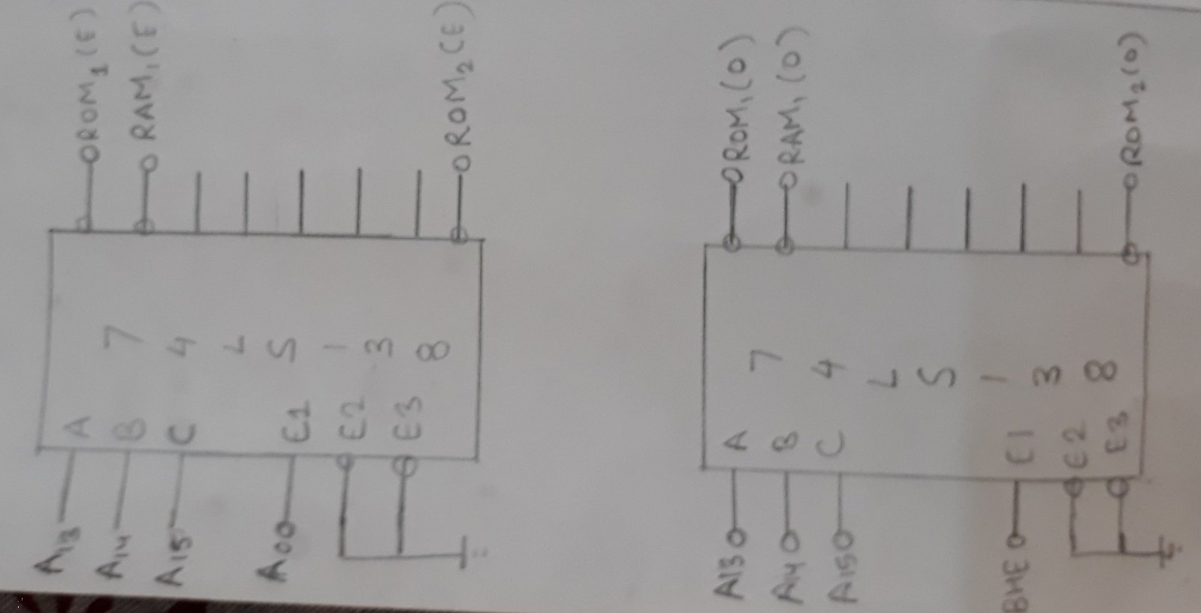

C:\Users\VISHAL0811\Desktop\mup pics\bl.jpg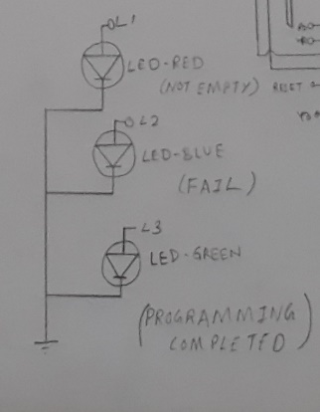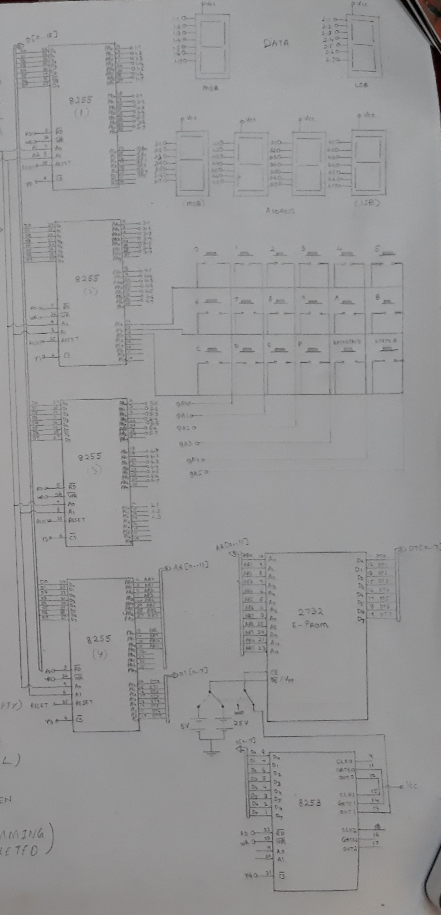

ALGORITHM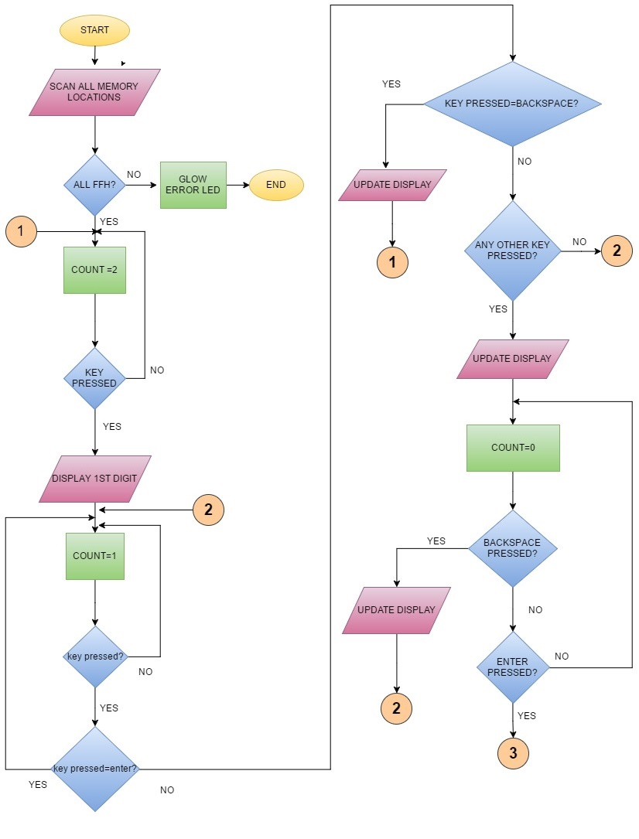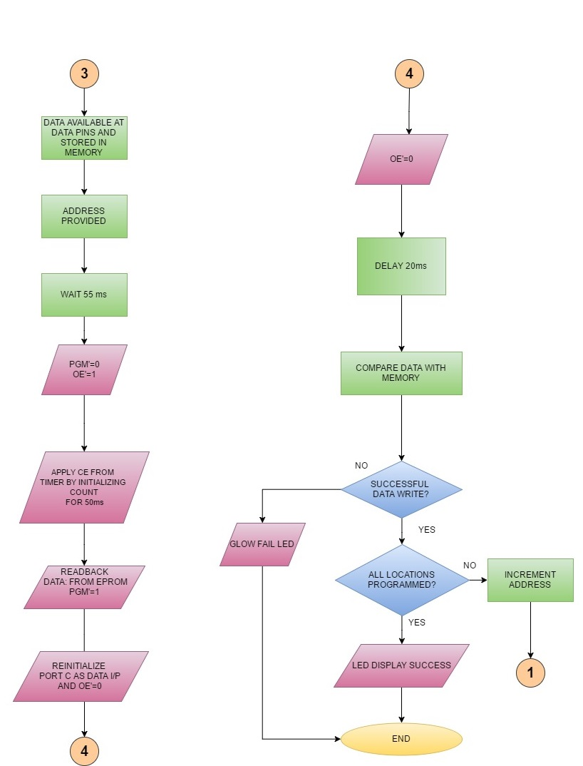



REFERENCE DATA SHEETS

1. 8086

<http://www.ece.cmu.edu/~ece740/f11/lib/exe/fetch.php?media=wiki:8086-datasheet.pdf>

2. 8055

<http://www.alldatasheet.com/view.jsp?Searchword=8055&sField=3>

3.8053

<http://www.alldatasheet.com/view.jsp?Searchword=8053>

4.27C64

<http://www.futurlec.com/Memory/2764_Datasheet.shtml>

c